Applications of Information and Communication Technologies

Project Proposal

Library Management System



**Submitted by**

|  |  |  |
| --- | --- | --- |
| Abdul Rahman |  | 2023-CS-725 |
| Muhammad Abdullah Khan |  | 2023-CS-718 |

**Submitted to**

Ms. Zoha

**Dated**

4th December, 2023

Department of Computer Science

University of Engineering and Technology Lahore, New Campus

# Table of Contents

Description 3

Objectives 3

Modules & Features 3

Header: 3

Footer: 3

Community Section: 4

Watch Together Page: 5

Hero Page: 6

Browse Anime Page: 7

Screen Page: 8

Conclusion: 10

# Table of Figures

Figure 1 Header: Search bar 3

Figure 2 Header: Navigation Bar 3

Figure 3 Footer 3

Figure 4 Community Page: Create Post 4

Figure 5 Community Page: Post 4

Figure 6 Community Page: Post Options 4

Figure 7 Watch Together Page: Live Chat 5

Figure 8 Watch Together Page: Screen 5

Figure 9 Hero Page: Comment Section 6

Figure 10 Hero Page: Schedule Section 6

Figure 11 Hero Page: Browse Button 6

Figure 12 Browse Anime: Genre Section 7

Figure 13 Browse Anime: Card Section 7

Figure 14 Player Page: Left Column 8

Figure 15Player Page: Right Column 8

Figure 16 Player Page: Screen 9

Figure 17 Player Page: Server Selection 9

Figure 18 Player Page: Season Selection 9

Figure 19 Player Page: Review 10

Anime Streaming Website

# Description

In our background study for the anime streaming website, we have features like synchronized watching, real-time chat, and options for private or public viewing. It's all about creating a user-friendly space for anime fans to enjoy their favorite shows together.

# Objectives

Our anime streaming site aims for synced viewing and chat experience. Our objective is to enhance user experience by providing with diverse collection of anime series, its community, and a welcoming user feedback.

# Modules & Features

## Header:

* User have a search bar on the top of the screen in whole website so that they can easily search any type of anime series as in Figure 1 Header: Search bar.

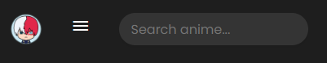

Figure 1 Header: Search bar

* User have the option to navigate through the website. And see the upcoming notification as in Figure 2 Header: Navigation Bar.

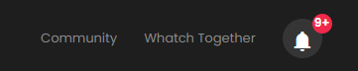

Figure 2 Header: Navigation Bar

## Footer:

* User can search their favorite anime in an alphabetical order and navigate to important documentation about copyright laws and the website’s policy as shown in Figure 3 Footer.

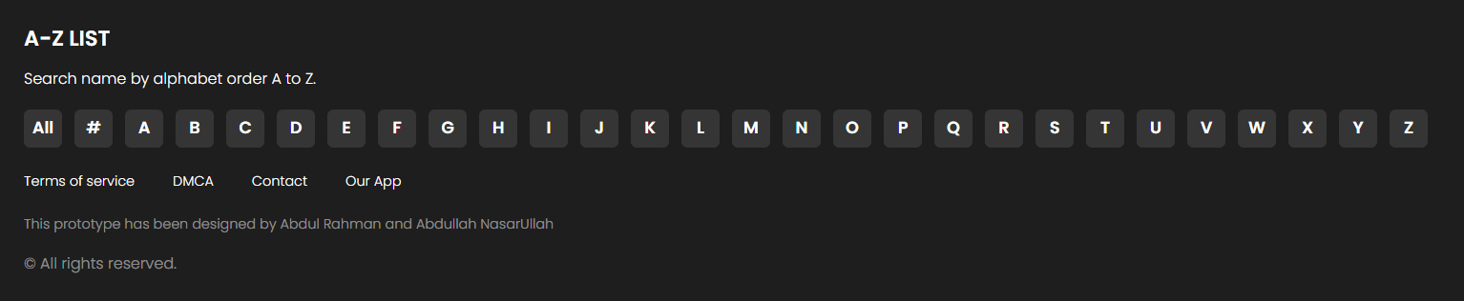

Figure 3 Footer

## Community Section:

This page contains user generated content, such as reviews, recommendations, and posts. User can follow other users and connect with fellow anime fans. They can communicate with discussion forums. It also contains user registration and profiles.

* User can post anime relate content with form shown as in

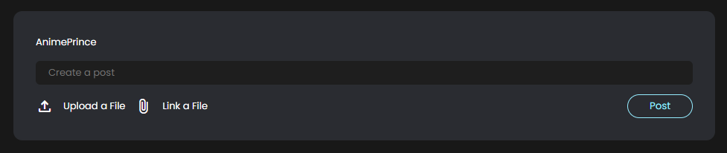

Figure 4 Community Page: Create Post

* User can start a discussion, spread news and talk about latest episodes

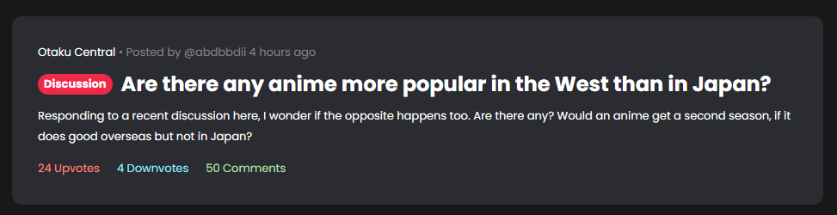

Figure 5 Community Page: Post

* User can upvote, downvote and comment on content.



Figure 6 Community Page: Post Options

## Watch Together Page:

This page consists of synchronized streaming for simultaneous viewing by multiple users, chat box feature for real-time interaction during streaming along with the option to create private or public viewing rooms.

* User can message publicly send messages using live chat option on the right side of the screen.

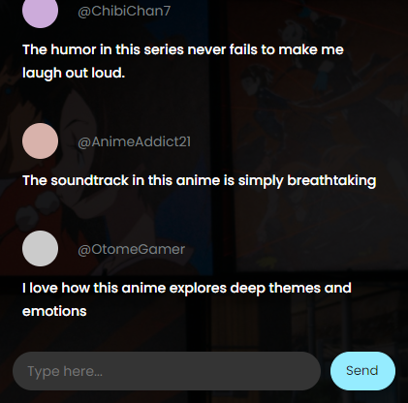

Figure 7 Watch Together Page: Live Chat

* The screen provides the information of how many viewers are currently watching, how much time has lapsed and who created the room.

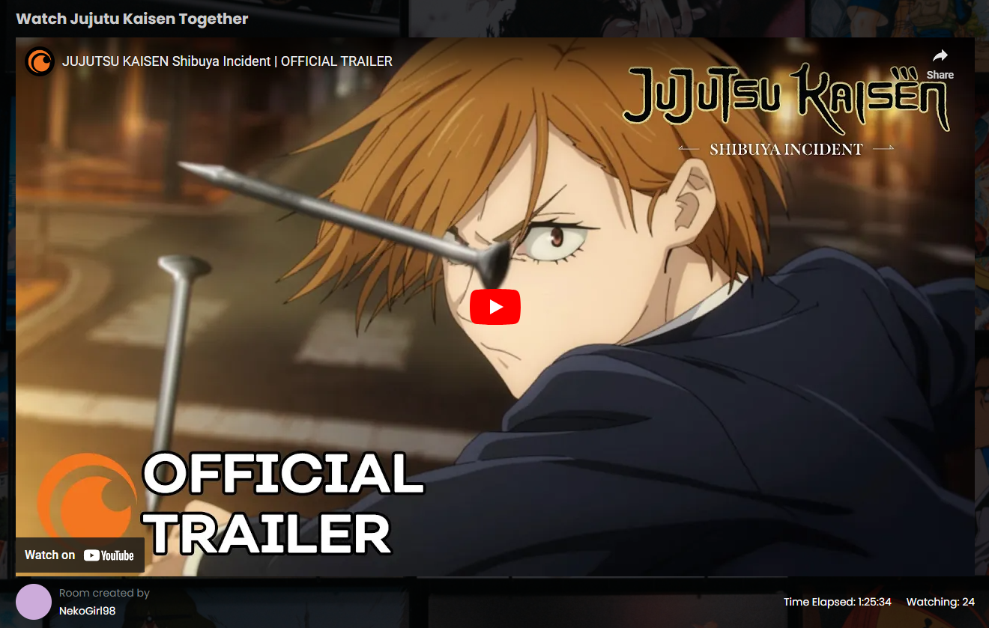

Figure 8 Watch Together Page: Screen

## Hero Page:

Discover anime easily on our site with user reviews and comments for top series. Dive into spotlights on favorite anime series. Stay updated with news about upcoming releases**.**

* User can see other people’s comments to better understand an anime.

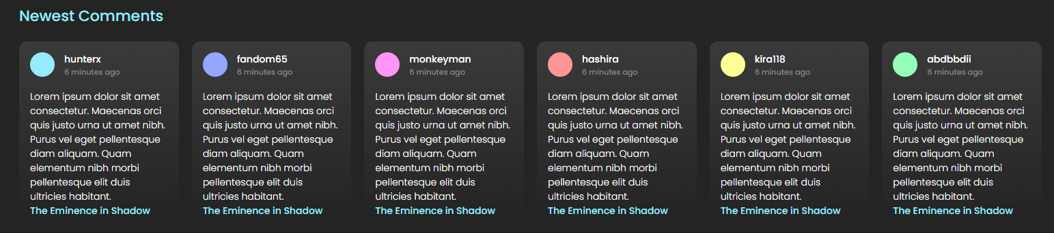

Figure 9 Hero Page: Comment Section

* User can stay up to date about the latest releases.

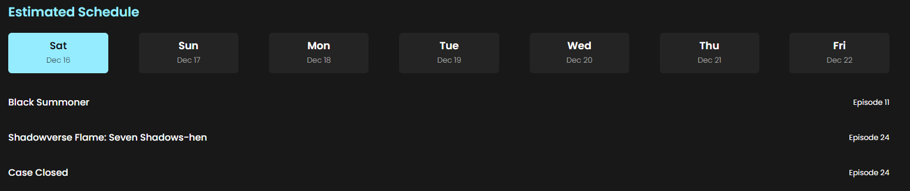

Figure 10 Hero Page: Schedule Section

* User can navigate to the anime list just by clicking a button.

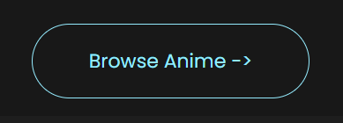

Figure 11 Hero Page: Browse Button

## Browse Anime Page:

Check out trending and top-rated series and get personalized recommendations based on genres, popularity, or your preferences.

* On the top of the webpage user can choose from the variety of different genres of their favorite likings.

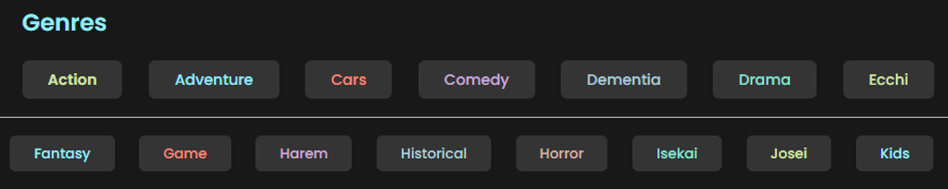

Figure 12 Browse Anime: Genre Section

* Below there is a section for
  + Trending
  + Latest Episodes
  + Top Upcoming
  + Most Liked

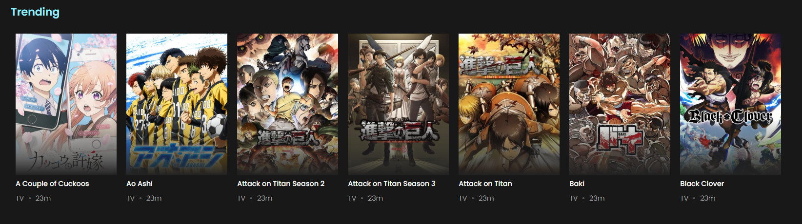

Figure 13 Browse Anime: Card Section

## Screen Page:

Watch anime on this page. Enjoy high-quality video with choices for resolution. Pick subtitles or dub for international viewing with multiple servers. Share your thoughts in the comment section.

* On the left side of the page user can select which episode of the series they want to watch.

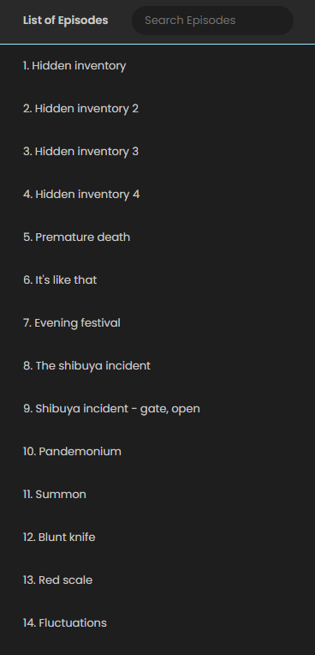

Figure 14 Player Page: Left Column

* On the right side of the webpage, user can get the information of the anime he is watching right now.

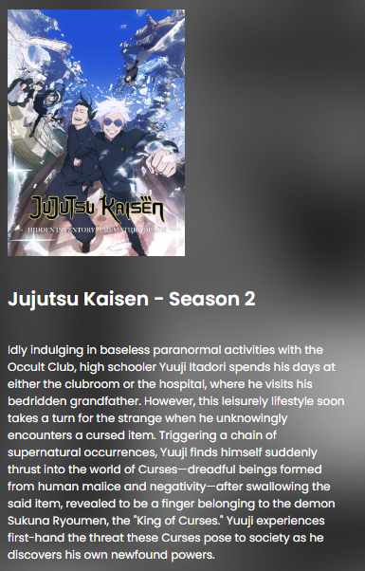

Figure 15Player Page: Right Column

* In the middle of the webpage, there is a player on which user can watch there show with options to
  + Expand
  + Turn Lights On/Off
  + Turn Auto Play On/Off
  + Turn Auto Next On/Off
  + Turn Auto Skip Intro On/Off
  + Edit Watch List
  + Watch Together



Figure 16 Player Page: Screen

* Right below the player, user can choose another server if for some reason the current server is not working.

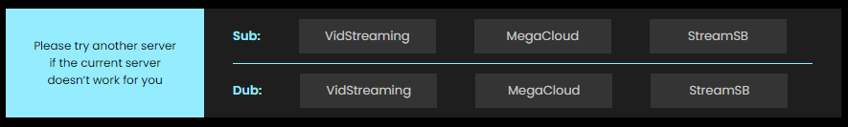

Figure 17 Player Page: Server Selection

* On the lower side of the player, user car choose seasons and parts of that anime.

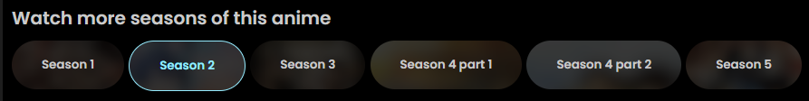

Figure 18 Player Page: Season Selection

* Finally, after watching an episode, user can help others by leaving a review.

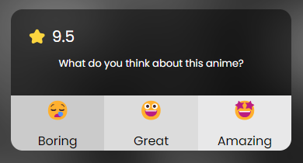

Figure 19 Player Page: Review

# Conclusion:

Overall, User can watch there shows with beautiful interface without any destraction. He can enjoy there favorite anime series with all useful features.